Name:________________________________

This quiz is NOT FOR A GRADE. It is simply an up-front assessment of your World Geography knowledge. I will use the information from your answers to enhance course lectures.

*There is a front and back page, please do both.

1. Lines of _______________________ run east to west and measure north to south, while lines of _________________________ run north to south and measure east to west.

2. The line of 0° **longitude** is called the ____________________________, and 0° **latitude** is called the ______________________.

3. Which of the following is the SMALLEST scale?

a) 1/10,000 b) 1/100,000 c) 1/1,000,000 d) 1/100

4. Name one of the Great Lakes._____________________________________________

5. On which continent is the South Pole located? ____________________________________

6. Which is the largest continent in terms of land mass? _____________________________

7. What is the name of the world’s longest river? ___________________________________

8. What is the capital of the United States? ________________________________________

9. What country borders the United States to the North? _______________________________

10. What country borders the United States to the South?_______________________________

11. The photo below shows what famous landmark? In what country is it located?____________________________________________________________________

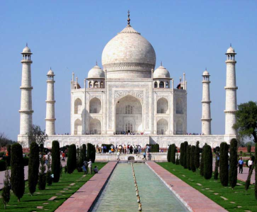

12. The Ayatollah Khomeini was the supreme leader and father of the Islamic Revolution in what country? __________________________

13. Are you from another country and/or have you ever travelled outside of the United States? If so, do you have any personal experiences or digital photos that you wouldn’t mind sharing with the rest of the class?________________________________________________________________________________

14. Is there a specific country you would really like to learn more about? Which one(s)? _____________________________________________________________________________________

